**Site: indrive.com**

1) Forwarding requests using Burpsuite:

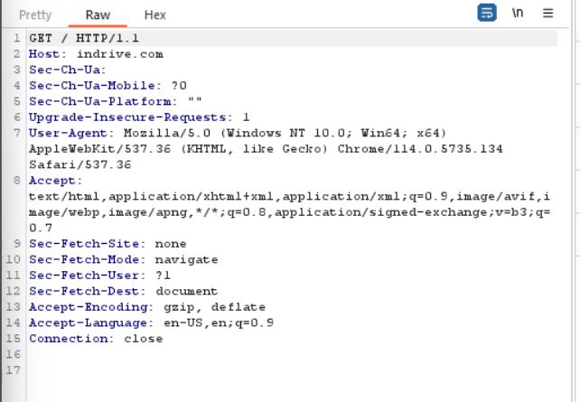

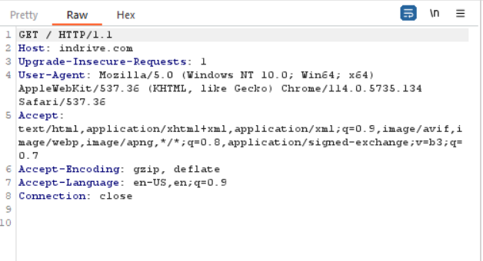

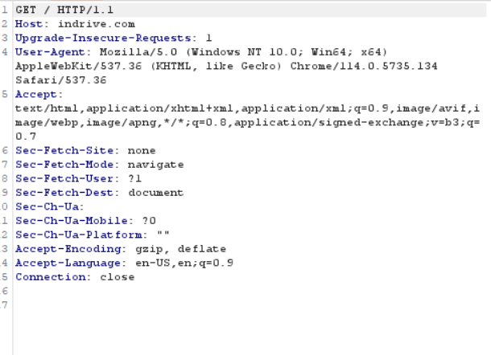

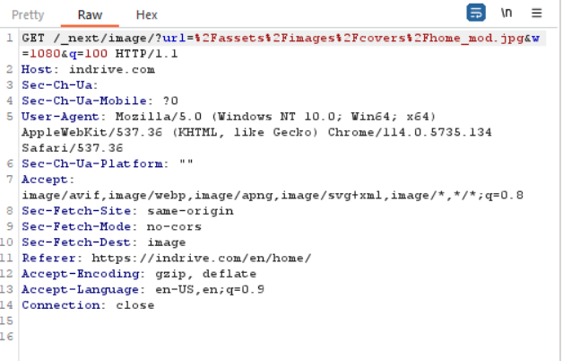

2) Comparing requests and responses using repeater:

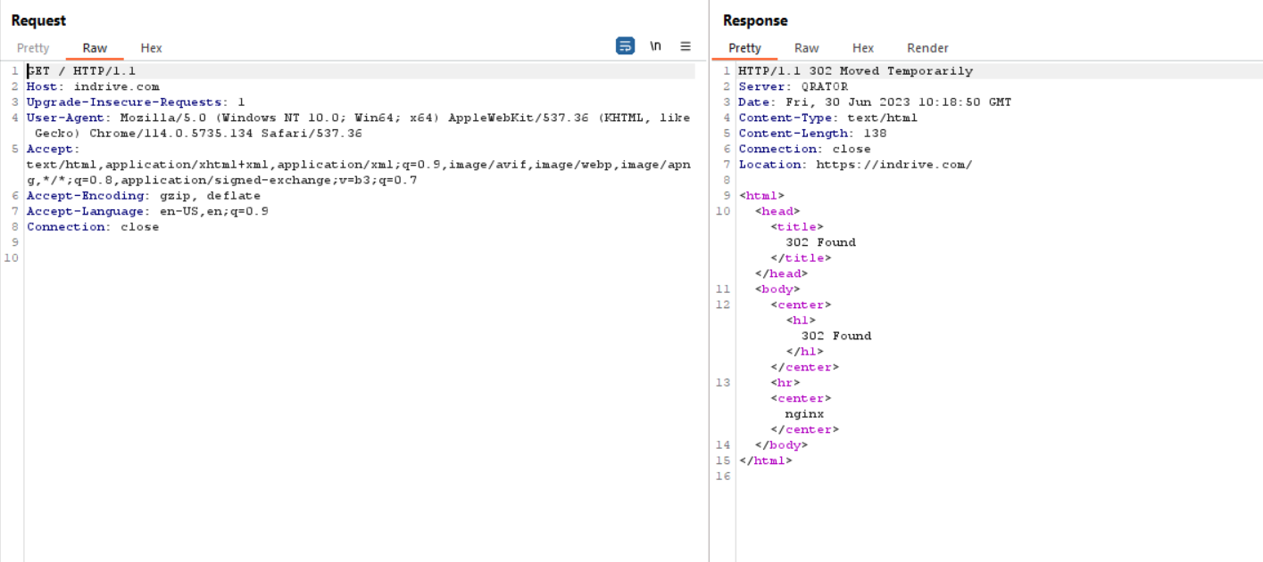

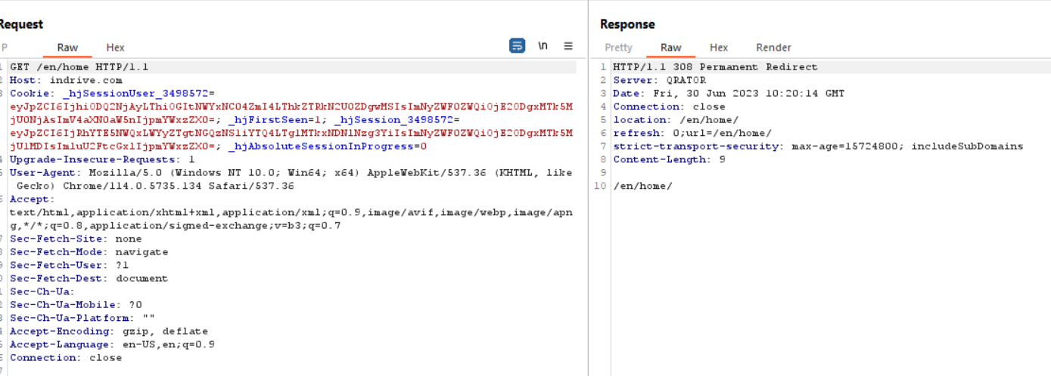

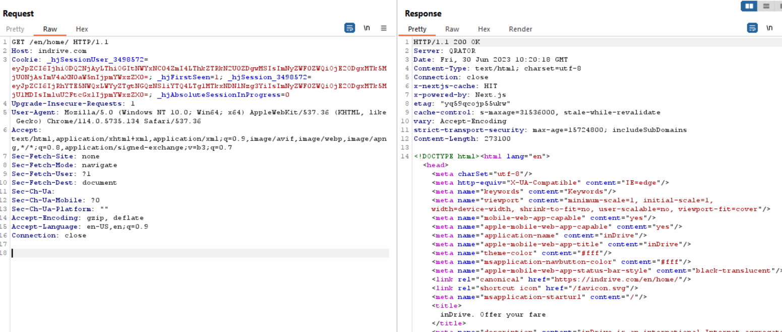

We can observe that there are multiple redirections before we reach the actual site.

3) Checking the log info using logger:

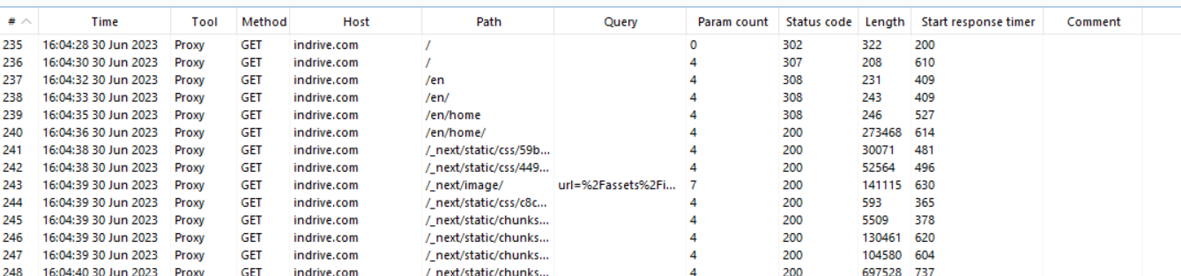

**Conclusion:**

Using Burpsuite on the site indrive.com, we can observe that they are 5 redirections before we reach the site (common feature of vulnerable website). We can also observe that requests use “GET” instead of “POST” and request also uses HTTP instead of HTTPS.